**Lab 3**

1. Recreate SSH key by using 2048 bit with SSH v2.0
2. Previous SSH version

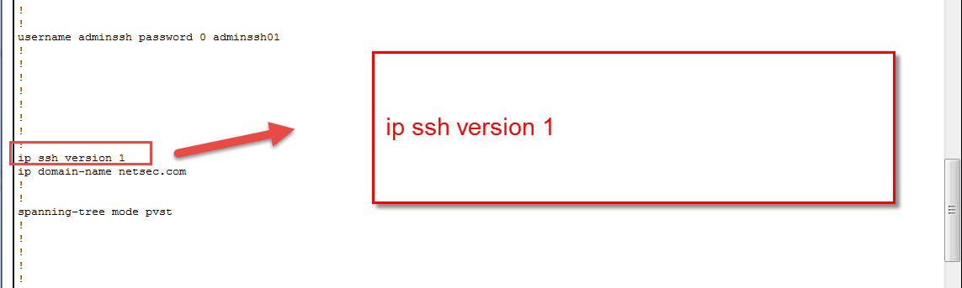

1. Changing

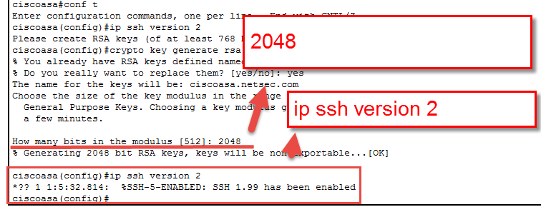

1. Post changing SSH version

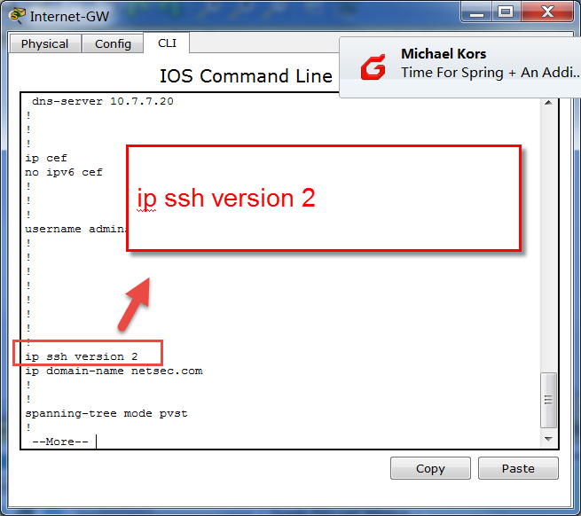

1. Create ACL and limit access to SSH to the Internet-GW router to only Student2-pc and apply it to the correct interfaces to limit access.
2. Access list

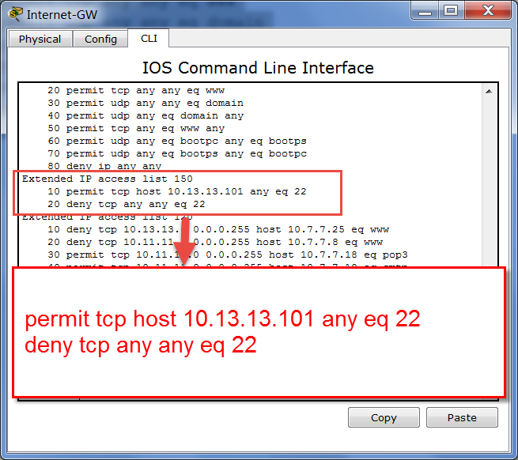

Description:

According to the requirement, only student 2 from engineering college (ip:

10.13.13.101) can SSH Internet/GW router (ip: 10.13.13.1). So, in this case, we set up ACL as above. And, we will default deny any other host to use SSH services. However, if we only want block other SSH to a specific router Internet/GW without block all other SSH connections, we need to change deny entry to

Deny tcp any 10.13.13.1 eq 22

1. Interface apply

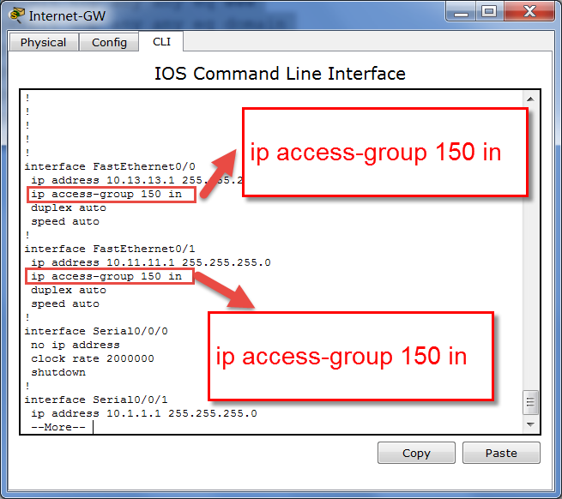

In this case, we applied to two interface: Fastethernet 0/0 and fastethernet 0/1. The reason is we need to block both Engineering Department and CCIS Department from sshing the Internet/GW router.

1. Verification

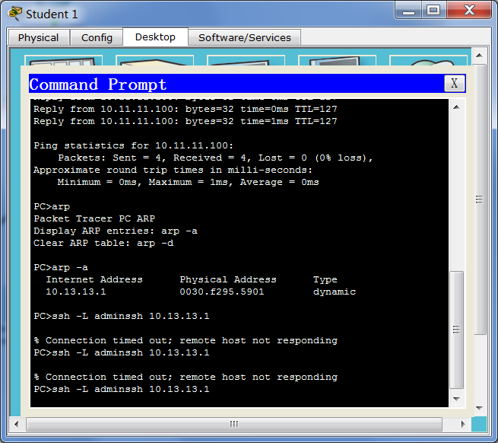

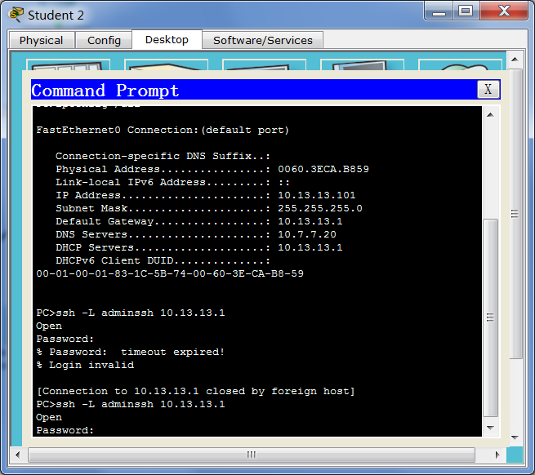

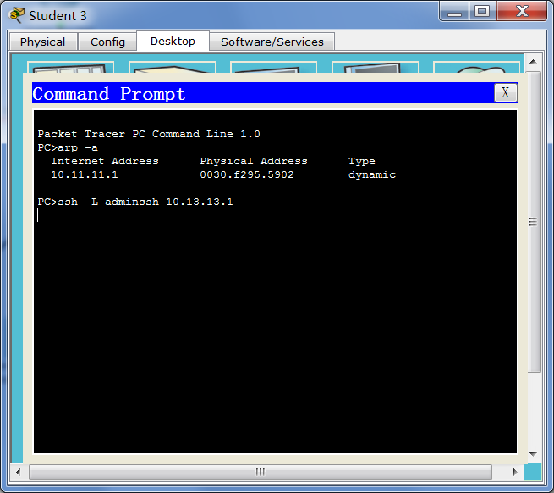

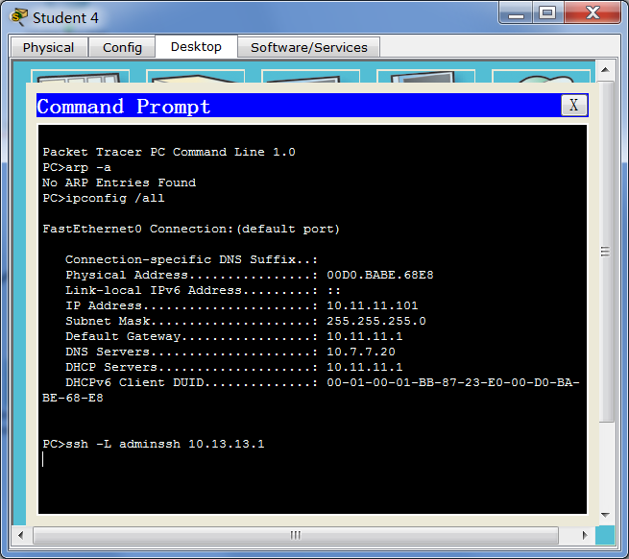

Only student 2 can SSH.

1. Site-To-Site VPN settings.
2. VPN configuration

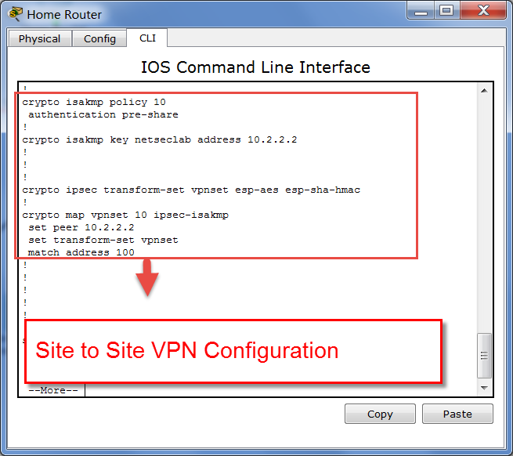

1. Results

